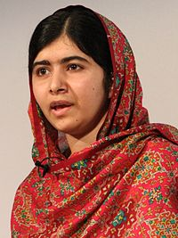
Malala Yousafzai – A Pakistani activist for education for women and girls and a Nobel Peace Prize Winner. Her activism and story has led to the founding of schools and the passage of Pakistan's first Right to Education Bill.

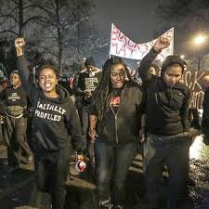
Millenials Activists United – Founded by local activists following Ferguson, Millennial Activists United is a Missouri-based, youth-led grassroots organization that focuses on educating and empowering our communities.

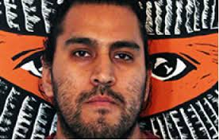
Javier Barrera Cervantes –A founding board member of the Latino Youth Collective, a program that provides resources and opportunities for youth to engage in personal and community development through critical pedagogy, grassroots organizing, and collective action. He also serves as the Director of the Campecine Youth Academy, a summer research program that trains and employs youth to conduct research and enact social change in their community.

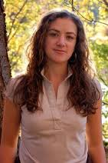
Courtney Martin - An American third wave feminist, author, speaker, and social and political activist. She is the author of several books and is known for co-editing the feminist blog, Feministing.com, and speaking at universities nationwide.

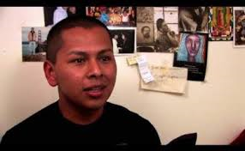
Jorge Gutiérrez – An undocumented queer activist and a DREAMer who brings LGBTQ and immigration activists together. He’s the national coordinator for FAMILIA TQLM, which currently focuses on LGBTQ immigrant rights in detention centers.

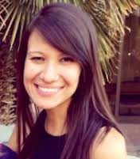
Megan Red Shirt-Shaw - A 27-year-old member of the Oglala Sioux tribe, and founder of an online literary publication written for — and by — young Native Americans called @NativeAmerica. The publication shows the world who Natives are as nation builders, leaders, artists, and as contemporary citizens

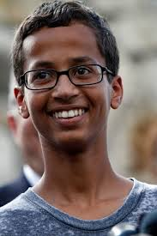
Ahmed Mohamed – A 14 year old, Texas scientist, recently arrested for bringing a clock to school. Weathering a national response, Ahmed has been invited to the White House, Google and Facebook headquarters and has been the recipient of support from dozens of national leaders.

